Year 12 ATAR PHYSICS
Practical Test WAVES AND QUANTA

Part A: DETERMINING PLANCK’S CONSTANT

Marks: /20

ANSWERS

Equipment operation:

(2 marks, -1 for each request for help, unless equipment problem related)

EXAMPLE DATA
V_{th} | (Read from the dial) | Frequency (f)
- Data column |  | - Calcs column
2.317 V | 465 nm | 6.45 X 10¹⁴ Hz
1.837 | 520 | 5.77
1.584 | 594 | 5.05
1.289 | 620 | 4.84
1.344 | 660 | 4.55
0.859 | 880 | 3.41
0.792 | 940 | 3.19

(2 marks)
1. Plot V vs f results on the following graph (grid over the page). (4 marks)
(1) scales (1) labels (2) accurate plotting
2. Line of best fit ignoring outliers (1 mark)

GRAPH:
1.0 2.0 3.0 4.0 5.0 6.0 7.0 8.0 9.0
2.5

2.0

1.5

1.0

0.5

0
V
O
L
T
S
FREQUENCY X 10¹⁴ HZ
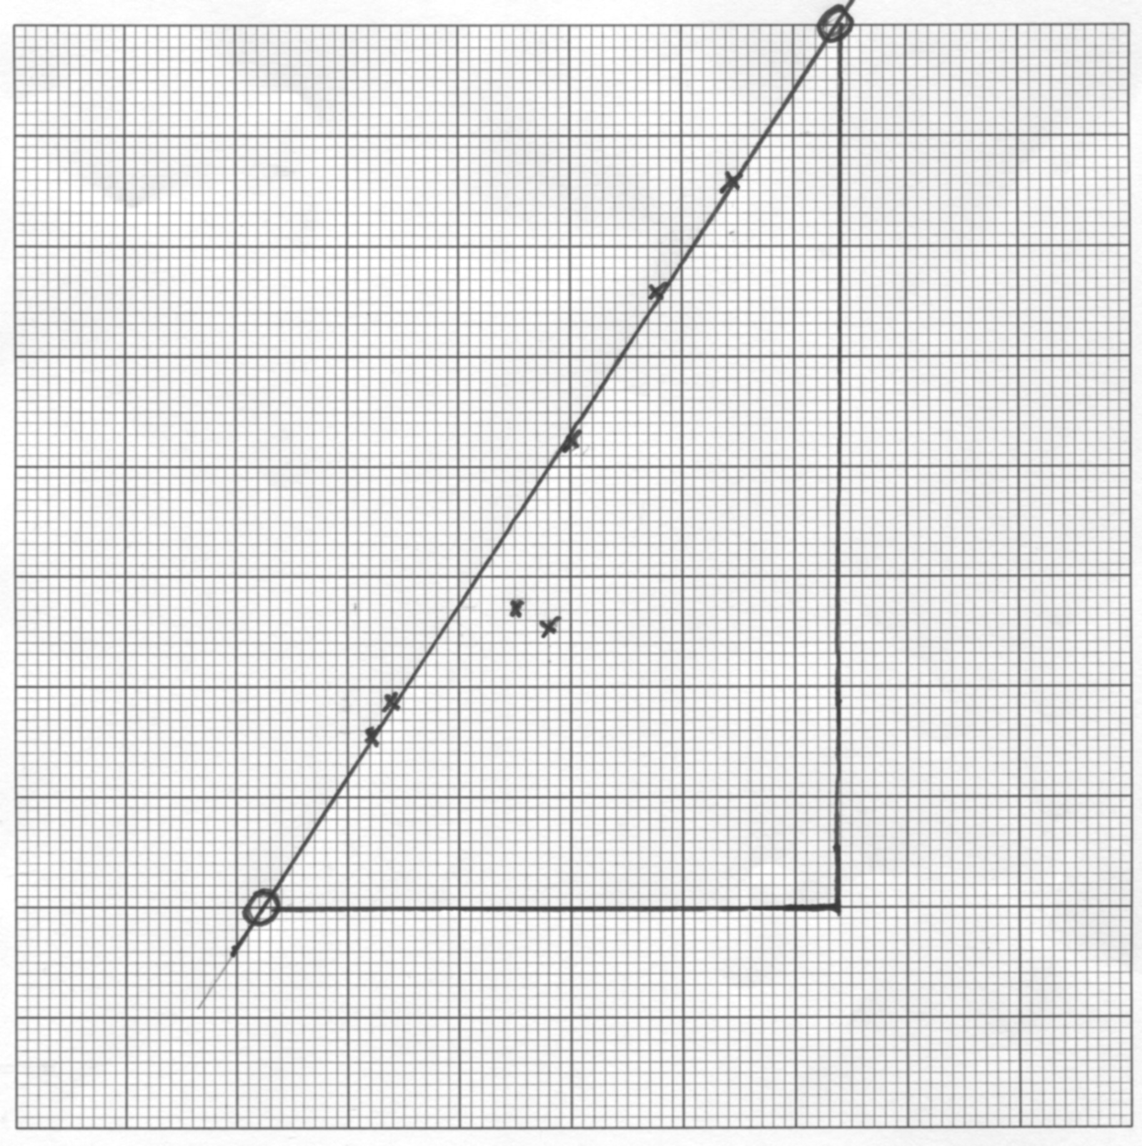
3. Calculate the gradient showing clearly on the graph where you have taken the points.
(3 marks)

Gradient = (2.5 - 0.5) (1) method shown on graph
(7.4 – 2.3) x 10¹⁴

= 3.85 x 10⁻¹⁵ Vs (1) ANS (1) units [VHz⁻¹ ok!]

4. Use the gradient to calculate h. (4 marks)
eV_{th} = hf , so V_{th} = hf / e
gradient = h/e
h = gradient x e = 3.85 x 10⁻¹⁵ x 1.6 x 10⁻¹⁹
= 6.2 x 10⁻³⁴ Js (1) (1) unit

2 sig figs (1)

Range: 6.0 - 6.4 x10⁻³⁴ Js (1) Ans in range

5. List one random error and one systematic error which may occur when conducting the above experiment: (2 marks)
Any reasonable answer, must be in correct category, such as:
RANDOM: Reading display on digital meters
Drawing line of best fit

SYSTEMATIC:
Resistance in wires (poor connections): (Random??)
Calibration of meters
Inaccurate value for wavelength of LEDS.

6. Identify two methods which would help to minimise the errors. (2 marks)
Use higher quality meters
Use high quality connectors, expand banana leads etc
Check wavelengths with spectrometer.
Repeat lab or combine class results.

